TEAM ID: PNT2022TMID41126

PROJECT NAME: DemandEst - AI powered Food Demand

Forecaster

TEAM LEADER

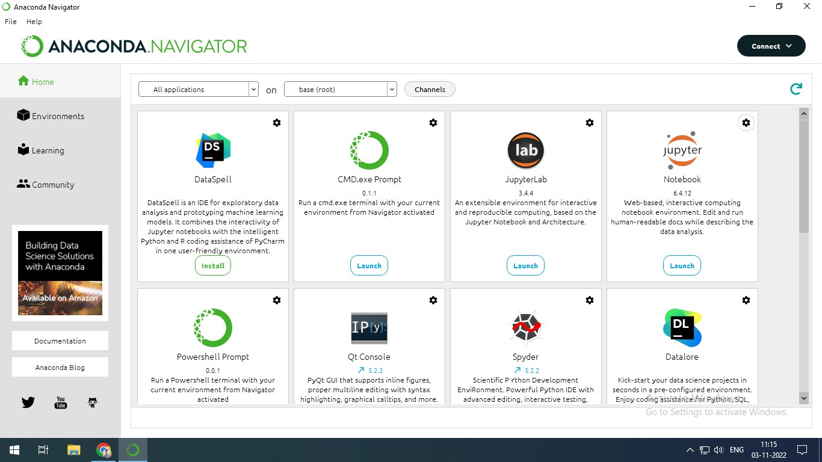

TEAM MEMBER 1

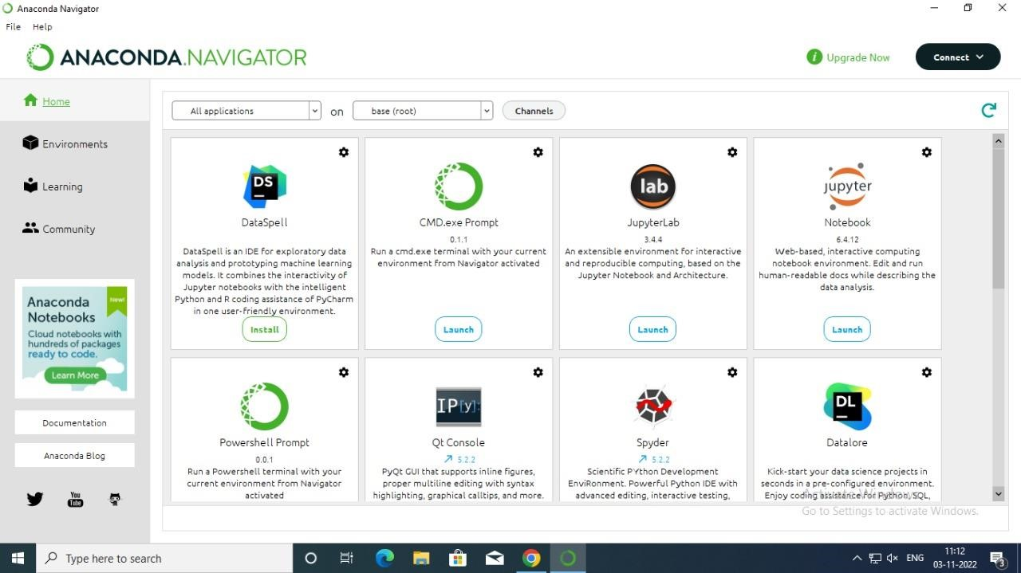

TEAM MEMBER 2



TEAM MEMBER 3

